Navigating in ActiveWorlds on a Laptop Computer:
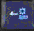 | 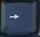 | 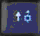
The left arrow key allows your avatar to move left. | The right arrow key allows your avatar to move right. | The up arrow key allows your avatar to move forward.
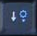 | 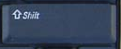 | 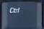
The down arrow allows your avatar to move backward. | The Shift key allows your avatar to move through objects such as walls.  (With the arrow key) | The Ctrl (control) key doubles your speed to when pressed with an arrow key.
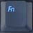 |  | 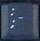
Press the Fn key or the function key when you want to use the + or – keys to fly. | Pressing the + key (on the numeric key pad) while the Fn key is pressed will enable you to fly up. | Pressing the – key (on the numeric key pad) while the Fn key is pressed will enable you to fly down.
 |  | 
The Page Up key allows you to look up. | The Page Dn key allows you to look down. | The End key cycles through different types of points of view.
 | 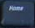
 | The Home key resets your view to first person.

